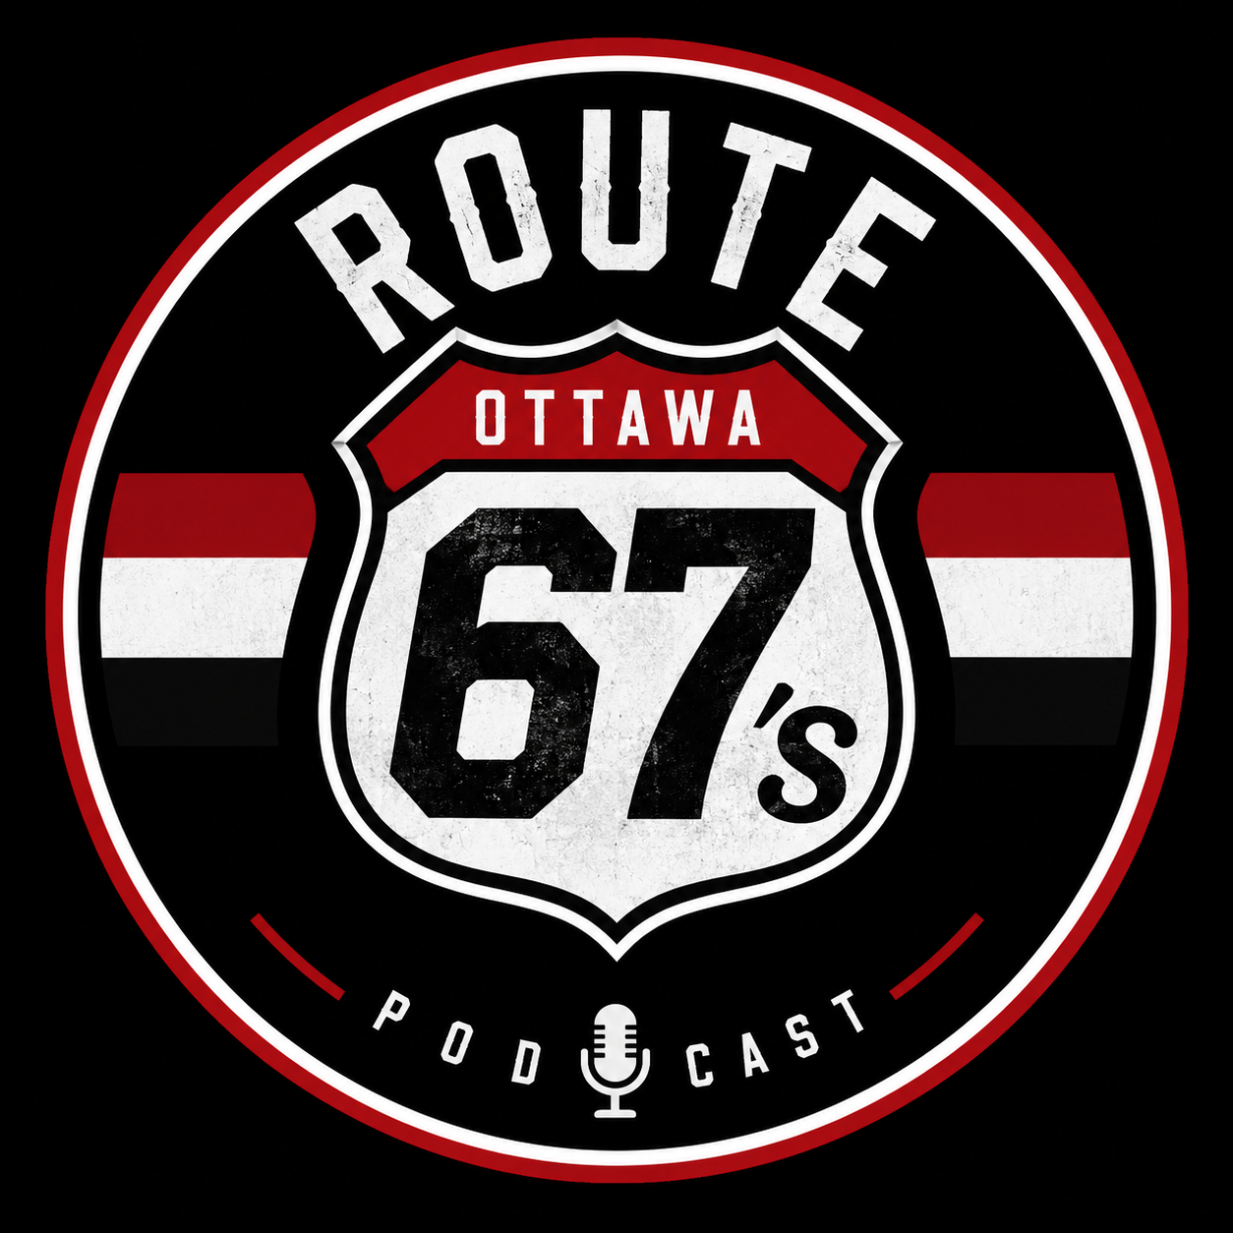
Route 67
An Official Ottawa 67's Podcast
Pitch prepared for: Adrian Sciarra, President & Alternate Governor, Ottawa 67's Hockey Club

1. The One-Line Pitch
Route 67 is a weekly podcast that takes fans inside every mile of the season — game breakdowns, prospect development, alumni stories, and the community that makes the 67's one of the OHL's flagship franchises — built to deepen fan loyalty and give the organization a new, always-on media asset.

2. Why Now
- OHL fanbases increasingly follow their teams through audio/video content between games, not just box scores. A team-branded podcast fills that gap and keeps fans engaged on non-game days.
- Other OHL and junior hockey markets have shown that team-affiliated podcasts build community, support ticket/merch sales, and create content assets the front office fully controls.

3. Show Concept & Format
Name: Route 67 — a nod to the historic highway, the team's number, and "the road" of a season/player journey.
Cadence: Weekly during the season (~34 weeks), biweekly or monthly in the off-season (draft, prospects, alumni).
Length: 30–45 minutes per episode.
Core segments (rotating):
- Game Recap & Preview — last game breakdown, next opponent scouting
- Player Spotlight — sit-down interviews with players, coaches, and staff
- Alumni Corner — conversations with former 67's who went on to the NHL/pro hockey
- Front Office Insider — occasional appearances from management on strategy, scouting, and franchise direction
- Fan Mailbag / Community — questions from season ticket holders and the local fanbase

4. Outline of Pilot Season (First 6 Episodes)
Ep. | Focus | Guest(s)
1 | Season kickoff, team outlook | Head coach or GM
2 | Rookie/prospect development | A first- or second-year player
3 | Behind the scenes at TD Place | Operations/game-day staff
4 | Alumni story | A notable 67's grad
5 | Rivalry deep dive | Beat reporter or analyst
6 | Fan mailbag + season check-in | Host solo or with a front-office guest

5. Why It Benefits the Organization
- Deepens fan engagement between games, especially with season ticket holders and families
- New sponsorship inventory — pre-roll, mid-roll, and segment sponsorships separate from existing broadcast/gameday assets
- Player and alumni brand-building — helps market draft-eligible prospects and keeps alumni connected to the franchise
- Owned media — content the organization controls end-to-end, rather than relying solely on third-party coverage
- Low cost, low lift — audio-first production with modest equipment and editing needs; can scale to video/YouTube later

6. What I'm Asking For
- A short meeting (15–20 minutes) to walk through the concept in person
- Access for interviews — occasional access to players, coaches, and alumni for guest appearances
- Organizational blessing to use the Route 67 name and 67's branding, and to be recognized as an official or affiliated team podcast
- Feedback on format, tone, and any topics that are off-limits or need front-office coordination

7. About the Hosts
- Colin Zappia
- Don Brennan
- Kenny Walls

Thank you for considering Route 67. Looking forward to the conversation.

